General Biology Year 11


Unit 2 – Solving problems to survive
Task 9: Extended Response – Exchange surfaces in plants

Name: | Teacher: | Date: | Score:  /20

Assessment type: Extended response

Conditions

Time for the task:
- Part 1: One lesson to research topic and complete notes at home.
- Part 2: One lesson for in-class validation – extended response exam style question.

Task Weighting 10%

Part 2: In-class assessment

Questions

Answer all questions in the space provided.

1.

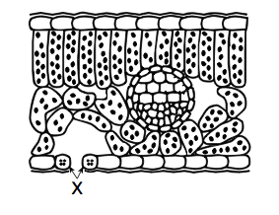

a. Name the structure labelled X on the diagram. ______________________________ (1)

b. Why is X found on the lower surface of the leaf? Give 2 reasons

____________________________________________________________________(1)

c. Using osmotic pressure, explain the role of the (guard cells) in gas exchange.

___________________________________________________________________________

___________________________________________________________________________

___________________________________________________________________________(3)

c. Explain why there are large spaces around X and the circular structure in the middle.

_____________________________________________________________________

_____________________________________________________________________ (2)

d. Transpiration is the evaporation of water from plants. Describe 3 factors that affect the rate of transpiration.

(3 marks)

Extended Answer Question: (10 marks)

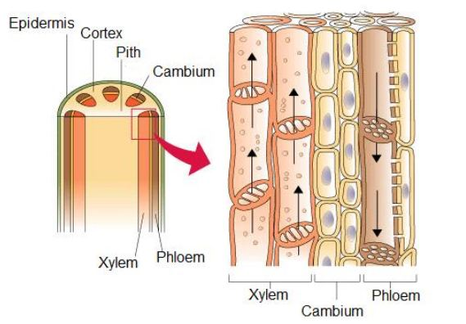

- Xylem and phloem transport various materials throughout a tree. Explain the differences between xylem tissue and phloem tissue. Your discussion should include the following:

- Structure of cells
- Properties of the cells (Similarities/differences).
- The substances that are transported
- The direction in which they are transported
- The source of energy for transport

End of assessment

